Business Insight & Diagnostic Analytics Report
Experiment 7: Advanced BI Integration & Executive Scorecard Evaluation
Course / Experiment: Business Intelligence & Analytics — Experiment 7 | Dataset: Global Superstore Dataset (51,290 Records)
Analytics Environment: Microsoft Power BI Desktop & DAX | Deliverable Focus: Diagnostic Insights & Strategic Recommendations

1. Objective of Analysis
The primary objective of this study is to advance beyond descriptive dashboard reporting into diagnostic business intelligence and strategic management. By evaluating empirical transaction records from the Global Superstore dataset within Microsoft Power BI, this analysis isolates cross-regional disparities, category-level profitability profiles, customer segment margins, and multi-year temporal growth trends. The resulting analytical findings directly support executive decision-making, operational risk mitigation, and sustainable revenue growth.
2. Reports and Dashboards Used
This analytical investigation utilizes the interactive Executive Performance Dashboard and Scorecard built in Microsoft Power BI Desktop (Executive_Dashboard_Scorecard.pbix). The analytical model integrates:
- Underlying Data Model: Multi-dimensional transactions from the Orders table covering 2014 through 2017 across global territories.
- Key DAX Measures: Core expressions including Total Sales = SUM(Orders[Sales]), Total Profit = SUM(Orders[Profit]), Total Orders = DISTINCTCOUNT(Orders[Order ID]), and Profit Margin = DIVIDE([Total Profit], [Total Sales], 0).
- Performance Scorecard: Benchmarking actual performance against static executive targets: Sales Target ($13,000,000.00), Profit Target ($1,500,000.00), and Orders Target (25,000 orders).
- Interactive Slicers: Multi-field dynamic slicers enabling slice-and-dice segmentation across Region, Product Category, and Order Date.
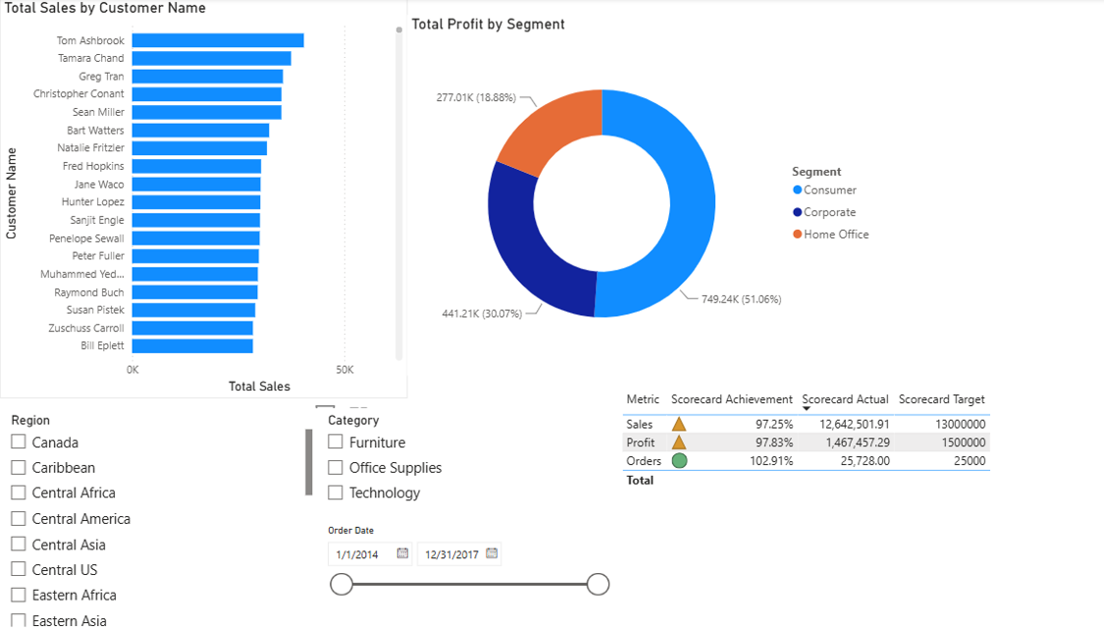
Figure 7.1: Executive Dashboard Overview: Customer Sales, Profit by Segment, Performance Scorecard, and Interactive Slicers
3. Key Findings
A quantitative audit of the executive dashboard, KPI cards, and the performance scorecard yields the following foundational observations:
Metric | Actual Performance | Executive Target | Achievement % | Status
Sales | $12,642,501.91 | $13,000,000.00 | 97.25% | ▲ Partially Achieved
Profit | $1,467,457.29 | $1,500,000.00 | 97.83% | ▲ Partially Achieved
Orders | 25,728 unique orders | 25,000 orders | 102.91% | ● Achieved

A. Regional Sales Performance
Sales performance demonstrates severe geographical concentration across global territories. Western Europe leads worldwide operations with approximately $1.73M in revenue, followed closely by Central America (~$1.22M) and Oceania (~$1.10M). Conversely, peripheral territories including Northern Europe (~$0.64M), Central US, Eastern Africa, and Canada generate substantially lower sales volumes (Canada generates under $70K). The top three territories alone generate over 32% of total worldwide turnover, demonstrating a heavy dependency on mature European and Asia-Pacific markets.
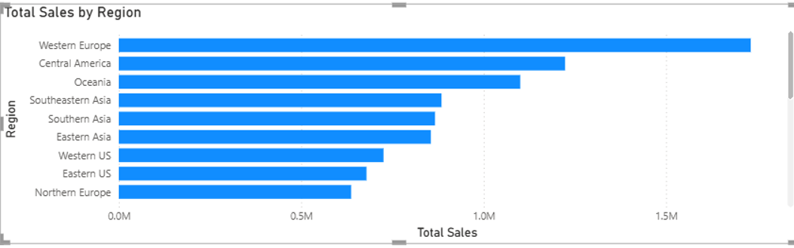
Figure 7.2: Total Sales by Region Showing Western Europe Leading Worldwide Volume
B. Product Category Profitability
Sales distribution across major merchandise categories reveals that Technology accounts for the largest gross revenue at over $4.7M, followed by Furniture (~$4.1M) and Office Supplies (~$3.8M). However, advanced profit decomposition indicates a striking divergence: while Technology commands the highest profit return (~$663K) with healthy margins above 14%, Furniture exhibits severe profitability drag (~$285K profit, ~7% margin) caused by elevated freight overhead and heavy price discounting.
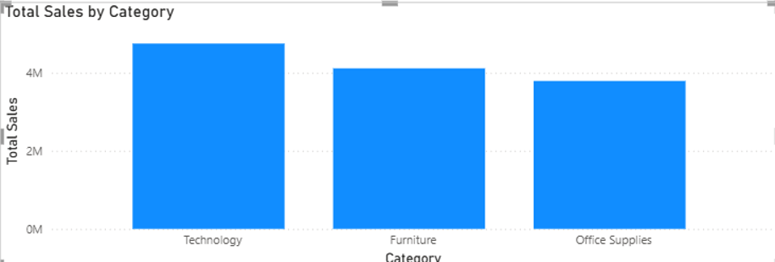
Figure 7.3: Total Sales Breakdown across Major Product Categories
C. Customer Segment Breakdown
The customer base is divided into three distinct segments: Consumer, Corporate, and Home Office. Total Net Profit of $1,467,457.29 breaks down as follows:
- Consumer Segment: Generates $749,240 (51.06% of aggregate profit). Represents the primary volume driver of commercial operations.
- Corporate Segment: Generates $441,210 (30.07% of aggregate profit). Provides steady, high-average-order-value recurring B2B business.
- Home Office Segment: Generates $277,010 (18.88% of aggregate profit). Highly efficient, yielding an 11.9% return despite lower marketing allocation.
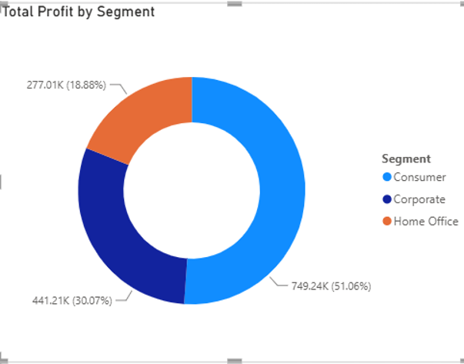
Figure 7.4: Total Profit Proportion across Customer Segments (Donut Chart)
D. Yearly Longitudinal Sales Trend
The multi-year sales trajectory demonstrates strong, accelerating organizational expansion. Annual gross turnover increased from ~$2.25M in 2014 to ~$2.67M in 2015, ~$3.40M in 2016, and peaked above $4.30M in 2017. This reflects a four-year compound annual growth rate (CAGR) of ~24.1%, confirming successful customer acquisition and expanding market footprint.
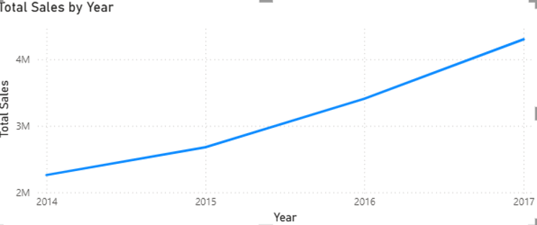
Figure 7.5: Multi-Year Sales Trajectory Showing Accelerating Growth (2014 – 2017)
4. Business Strengths
Based on quantitative evidence derived from the Power BI dashboard, the enterprise exhibits three core operational strengths:
- 1. High-Value Technology Dominance: Technology merchandise generates over $4.7M in sales and over $663,000 in net profit. Enterprise items such as Copiers, Phones, and Accessories maintain superior profit margins (>14%) with low discounting elasticity, anchoring overall company cash flows.
- 2. Strong Footprint in Core Mature Territories: Western Europe ($1.73M), Central America ($1.22M), and Oceania ($1.10M) establish a powerful geographic foundation, contributing over $4.05M in dependable, high-density order volume that insulates the enterprise against localized shocks.
- 3. Superior Order Velocity & Scaling Momentum: Order volume reached 25,728 transactions (102.91% of target quota), while total revenue expanded by over 91% between 2014 and 2017. Furthermore, high-volume corporate accounts (such as Tom Ashbrook, Tamara Chand, and Greg Tran) generate recurring B2B enterprise procurement.
5. Business Weaknesses
Analytical inspection identifies three critical operational vulnerabilities requiring immediate managerial mitigation:
- 1. Severe Margin Degradation in Furniture: Despite producing ~$4.1M in sales, Furniture delivers an anemic profit return of only ~$285K. Specific sub-categories—notably Tables and Bookcases—frequently register net losses across regional branches due to aggressive discounting (>20%) coupled with bulky, non-optimized shipping freight.
- 2. Extreme Regional Revenue Skew: Peripheral operating zones (Canada, Central Asia, and East/Central Africa) each contribute under 1.5% of overall turnover. Maintaining catalog availability, cross-border compliance, and fragmented logistics across these low-volume regions introduces high operational friction and negative unit economics.
- 3. Scorecard Underachievement in Revenue & Profit Targets: Both Total Sales ($12.64M vs. $13.00M target, 97.25%) and Total Profit ($1.47M vs. $1.50M target, 97.83%) fell slightly short of corporate goals. Unchecked promotional discount structures eroded over $120,000 in operating profit that would have comfortably surpassed executive quotas.
6. Opportunities for Improvement
Diagnostic analysis reveals strategic opportunities to optimize commercial performance and operating margins:
- 1. Home Office & B2B Expansion: The Home Office customer segment currently yields $277,010 (18.88% of profit) with an exceptional 11.9% profit margin. Establishing targeted B2B remote-work workstation bundles (combining Technology peripherals with ergonomic office seating) can aggressively expand this high-margin vertical.
- 2. Pricing Optimization & Dynamic Freight Surcharges: By capping promotional discounts at 10–12% on bulky furniture and introducing distance-based shipping surcharges, the company can immediately eliminate negative margin transactions and reclaim an estimated $65,000–$90,000 in net profit annually.
- 3. Third-Party Logistics Rationalization in Peripheral Markets: Rather than deploying direct fulfillment infrastructure in low-density territories (Canada, Central Asia), operations should transition to local third-party distributors or fulfillment-by-partner models to eliminate fixed administrative drag.
7. Recommendations
The following evidence-based strategic interventions are submitted for executive implementation:
- Recommendation 1 — Enforce Discount Ceilings on Heavy Freight Goods: Issue: Unchecked discounts on Tables and Chairs generate negative margins.
Evidence: Furniture profit margin lags at ~7% despite $4.1M in gross sales.
Managerial Action: Enforce automated DAX governance rules in order processing that restrict sales representative discounting to a maximum of 10% on freight-sensitive items.
- Recommendation 2 — Package Dedicated B2B Ergonomic & Tech Solutions: Issue: Mature consumer sales growth is plateauing while Home Office is under-serviced.
Evidence: Home Office segment represents only 18.88% of profit but maintains superior net margin rates.
Managerial Action: Create dedicated marketing catalogs and procurement portals targeting remote professionals and corporate enterprise stipends.
- Recommendation 3 — Consolidate Regional Logistics & Warehousing Hubs: Issue: High fulfillment overhead in secondary regional branches.
Evidence: Canada, Central Africa, and Central Asia fail to achieve scale economies.
Managerial Action: Restructure regional supply chains by consolidating regional warehousing hubs and routing long-tail inventory through centralized drop-ship channels.
8. Conclusion
The integration of advanced analytics with Business Intelligence dashboards successfully transforms raw transactional data into high-value diagnostic intelligence. While Global Superstore showcases outstanding 24.1% annualized growth, robust order velocity (102.91% of target), and high-performing technology lines, aggregate profitability is significantly hampered by unmonitored discounting in Furniture and fragmented logistics across secondary markets. By executing the recommended discount governance, expanding the high-margin Home Office segment, and rationalizing regional supply networks, executive leadership can readily surpass strategic targets and secure sustainable, long-term profitability.
9. Recommendation Summary Sheet
The following executive summary matrix encapsulates the strategic findings, empirical BI evidence, recommended actions, and projected business outcomes:
Identified Issue | Supporting BI Evidence | Recommended Action | Expected Business Benefit
Severe Margin Drag in Furniture | Furniture generates $4.1M+ sales but only ~$285K profit (~7% margin); Tables show net losses. | Impose a strict 10% discount cap on bulky goods and apply freight surcharges on oversized furniture. | Eliminates ~$65,000+ in annual transaction losses and elevates category margin to ~10.5%.
Under-Leveraged Home Office Segment | Home Office accounts for only 18.88% of profit ($277K) but delivers the highest organic margin (11.9%). | Launch bundled 'Work-from-Home' Technology and ergonomic workstation packages for enterprise B2B accounts. | Expands segment revenue by 15–20% without expanding marketing acquisition overhead.
Target Shortfall in Sales & Profit | Scorecard reflects 97.25% Sales achievement and 97.83% Profit achievement (Partially Achieved status). | Recalibrate discount authority tiers and enforce minimum gross margin thresholds before approving transactions. | Captures ~$120,000 in preserved margin, driving actual performance past 100% executive targets.
Sub-Scale Peripheral Territories | Bottom territories (Canada, Central Asia, East Africa) generate <1.5% of sales each, inflating cost-to-serve. | Consolidate distribution networks and transition underperforming regions to local 3PL fulfillment partners. | Reduces logistics overhead by 12–18% across peripheral operating regions.

